AWS Advanced Services :

AWS Step Functions :

1. AWS Step Functions lets you coordinate multiple AWS services into serverless workflows so you can build and update apps quickly.

2. Using Step Functions, you can design and run workflows that stitch together services such as AWS Lambda and Amazon ECS into feature-rich applications.
Workflows are made up of a series of steps, with the output of one step acting as input into the next.

3. Application development is simpler and more intuitive using Step Functions, because it translates your workflow into a state machine diagram that is easy
to understand, easy to explain to others, and easy to change.

4. You can monitor each step of execution as it happens, which means you can identify and fix problems quickly.

5. Step Functions automatically triggers and tracks each step, and retries when there are errors, so your application executes in order and as expected.

Benefits :

1. Build and update apps quickly
AWS Step Functions lets you build visual workflows that enable fast translation of business requirements into technical requirements.
You can build applications in a matter of minutes, and when needs change, you can swap or reorganize components without customizing
any code.

2. Improve resiliency
AWS Step Functions manages state, checkpoints and restarts for you to make sure that your application executes in order and as
expected.
Built-in try/catch, retry and rollback capabilities deal with errors and exceptions automatically.

3. Write less code
AWS Step Functions manages the logic of your application for you, and implements basic primitives such as branching,
parallel execution, and timeouts. This removes extra code that may be repeated in your microservices and functions.

Use cases:

1. Data processing

Step Functions can help ensure that long-running, multiple ETL jobs execute in order and complete successfully,
instead of manually orchestrating those jobs or maintaining a separate application.

You can also use Step Functions to standardize a machine learning training workflow to improve the accuracy of
machine learning models.

2.Automate tasks

Step Functions provides auditable automation of routine deployments, upgrades, installations, and migrations.

You can use Step Functions to easily automate recurring tasks such as patch management, infrastructure selection,
and data synchronization, and Step Functions will automatically scale, respond to timeouts, and retry failed tasks.

3.Modernize a monolith

By using Step Functions to carve off a few tasks from the rest of your codebase, you can tackle the transformation of
monolithic applications into microservices as a series of small steps.
.
This allows you to untangle business-critical code safely and at your own pace, without disrupting operations
and while you continue to deliver new features.

4.Application orchestration

Use Step Functions to combine multiple AWS Lambda functions into responsive serverless applications and microservices,
without having to write code for workflow logic, parallel processes, error handling, timeouts or retries.

You can also orchestrate data and services that run on Amazon EC2 instances, containers, or on-premises servers.

How to Create a Step Function and Integrate with other AWS Services :

Step Functions ->
Create a State Machine
1. Define State Machine
Author with code Snippets( Sample Code Editor in Amazon State Language (ASL) Where in we can define our Steps one by one .
Sample Projects
Templates
        - Configure Settings

AcloudGuru – AWS Lambda :

AWS Lambda Service:

Aws Lambda Serverless → Serverless means that we are not in charge of servers . Still there are Servers.

Tenets of Serverless :
1.You bring the code , Provider Brings the Infrastructure
    - Scale Seamlessly with demand
    - Pay As you Go , But never pay for Idle Time

For Example :

Lambda Runs when there is an Event for Nginx or Apache , else it will not run the event . But when you are running the Ec2 Instance , we are acually managing Nginx, Apache and pay bills for it .

Serverless Components:

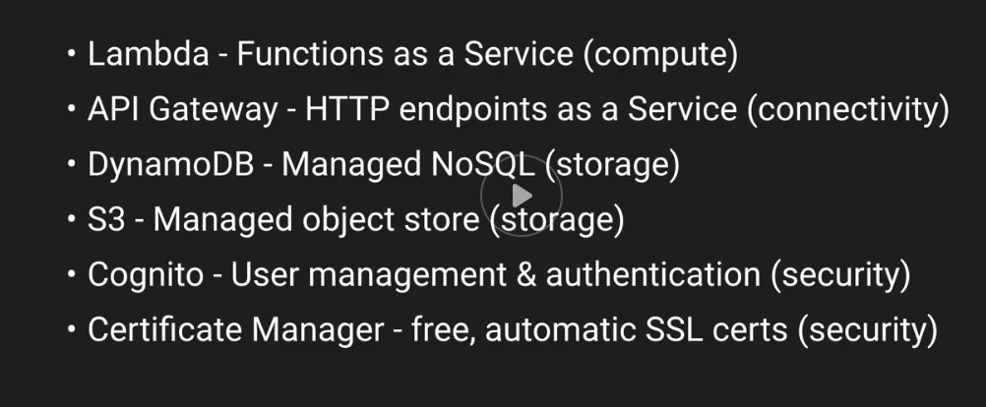

Use cases For Lambda :

    - ETL Jobs
    - API's (with API Gateway)
    - Mobile Backend.
    - Infrastructure Automation
    - Data Validation(Events are retiring Lambda can immediately react to the event without your intervention), remediate itself .
    - Security remediation (Security Automation , There are already Security Services Built around Lambda Function , one for which is AWS Config ,we can also supply custom Lambda Functions for Security )

How does Lambda work :

When You are Using Lambda you are also Using the other AWS Services like
    - Containers (Containers Running on Ec2 Instances, those Ec2 Instances are not accessible by you in terms of Administration or Management,They Download your code from Lambda into an Isolated Container , so looks like you there are isolated machines ,and you many lambda executing in that machine .
The Containers Enforce Resource Isolation (100 ms Execution , else Lambda process will be killed regardless of what state it might be ,)
    - Shared Ec2 Instances
    - Resource isolation
    - 100ms Execution measurement
    - 15 minute max
    - AWS SDK built-in

Event Sources :

Some of the event sources are listed below :

Schedules - Similar to your CRON Job
S3 Events - Hands over the info about Files (Added, deleted,Changed Files )
DynamoDB Streams – If there is a change in DynamoDB table ,Lambda is used to send the Event
API Gateway – Mapping Between Http Requests Coming in and Events being Send to Lambda Functions .

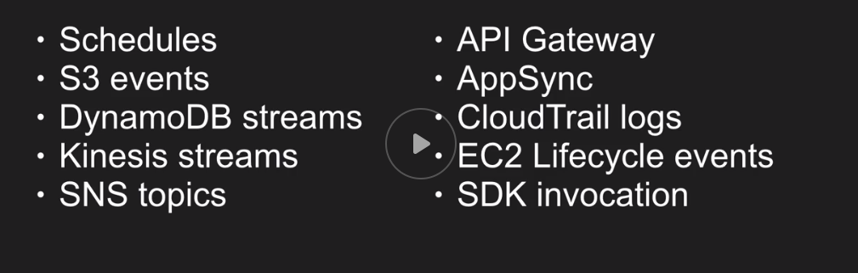

Example workflow :

Reacting to Files :
    - S3 is an Object Store
    - Lambda can receive Events
    - Code is stateless
    - Any Language of your Choice

Moving Parts :
    - Events Happens (Events coming From S3)
    - Function Recieves the event(Function Act when it receives the Event)
    - Custom Code runs

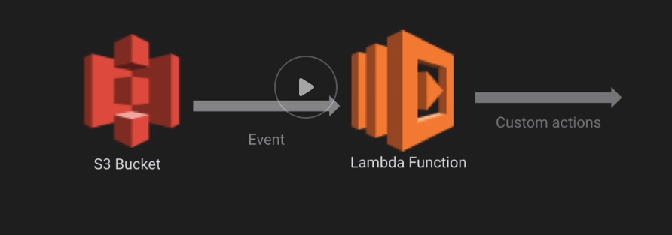

Here The S3 Bucket any file upload will trigger the Lambda function and your code doesnt have to POLL S3 asking (Is there any file upload ?)

Not having to POLL , saves you money directly through API calls ,meanign S3 will call you if there is something in there .

Many More Triggers:
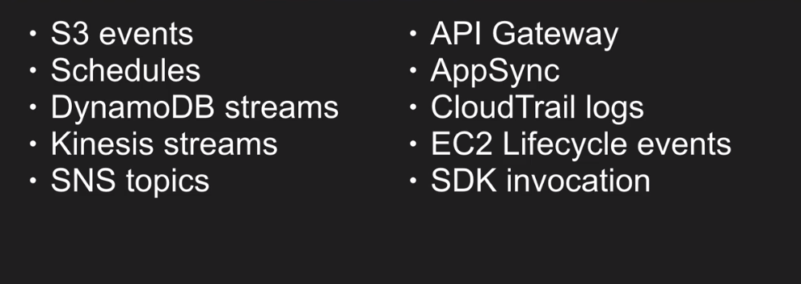

HANDLERS:
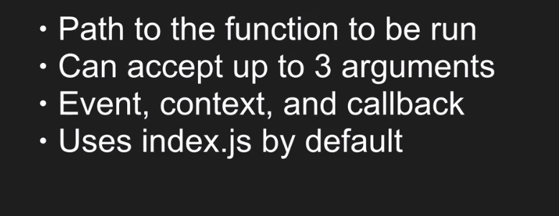

Memory And Performance:
Memory :
- CPU Scales with memory
- More Memory , More Amount to be paid
- Upto 3 GB RAM
- 128-3000 in 64 MB increments
- Also Network scales all together

Performance:
        - 2 vCPUs for 1500 -3008 MB
        - Parallel code can benefit

Testing and Logging:

We can test an event by Create Teest Event Tab .

Note : We can Have Multiple Events for One Lambda Function (For Test scenarios)
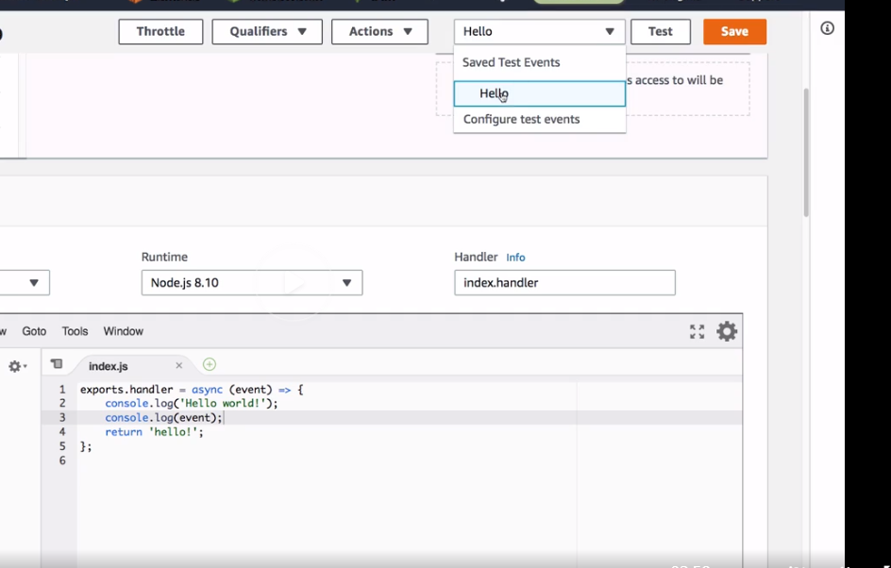

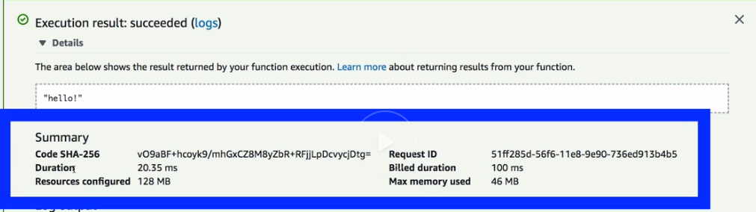

Summary of the Lambda Execution we can find from Expanding Execution Details .

We have used 128 MB RAM , to run the Lambda which is the default one .

We have been billed for Next Hundred . As in Screenshot we can see the execution time took only 20.35 ms But Billed Duration is 100 ms .

For example: If our function runs for 150ms it will be billed for 200ms .
It's always rounded UP.

Logging in Aws Lambda :(Done by Cloudwatch)

- Automatically collected and stored in Cloudwatch .
- No Library Needed for logs . console.log works
- Searchable
- TimeStamped automatically

Statelessness – State is offloaded somewhere else.

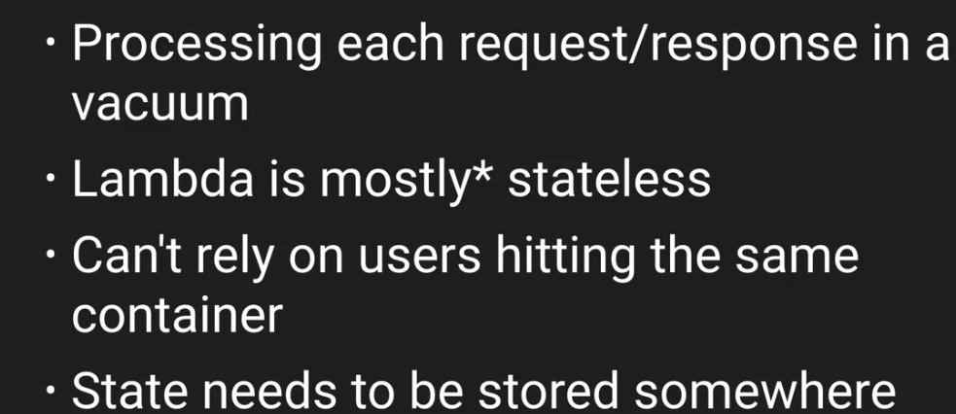

Stateful Vs StateLess

Stateless:
For Example you upload a Photo to Instagram API → Recieve a Sepia toned version back

Stateful:

Same above example :

Upload a Photo to API → Sepia Filter Added (Lambda)→ Output is stored in S3 Bucket → Url sent to User

Image is not sent back to user, rather URL sent to user

OUTSOURCING THE STATES :

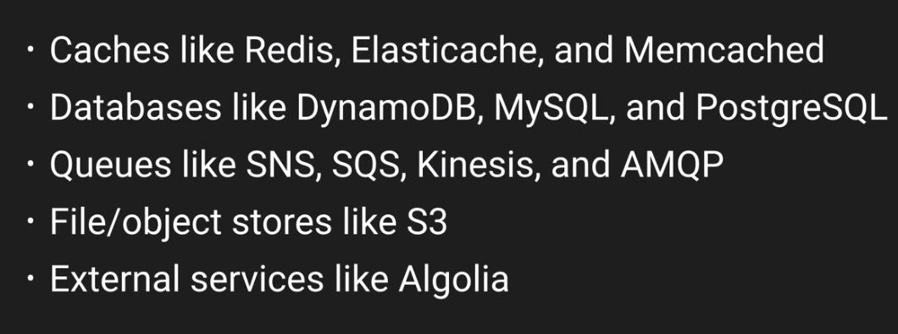

Lab 01 :

Using Lambda Console
1.Create an S3 Bucket .
2.Create a Lambda Function.
3.Create a Test Event in AWS Lambda
4.Cloudwatch logs gets automatically created after Triggering the Lambda test Event once .

Using AWS CLI :

Since the resource is Zipped .

zip csv_parse.zip *.js

aws lambda update-function-code --function-name guru-lab1 --zip-file file://csv_parse.zip

VERSIONING AND QUALIFIERS:

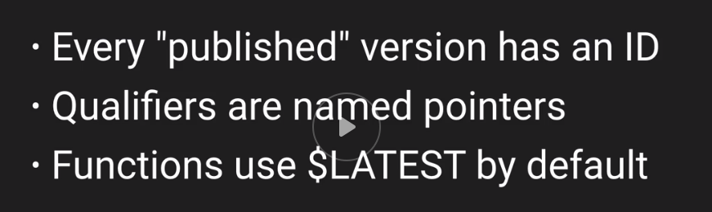
Qualifiers:

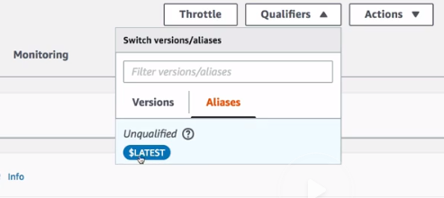
Versions :
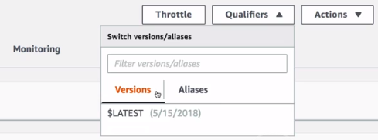

Publish New Version from Actions :
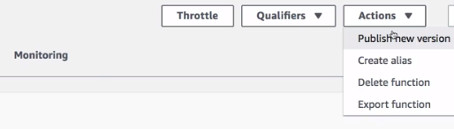
Once New Version is created in lambda , You will be noticing 2 changes ,

1. Title gets appended with 1:1 .
- And versions/aliases gets created . From The current version we can create an Alias and we can name it as Prod work environment .
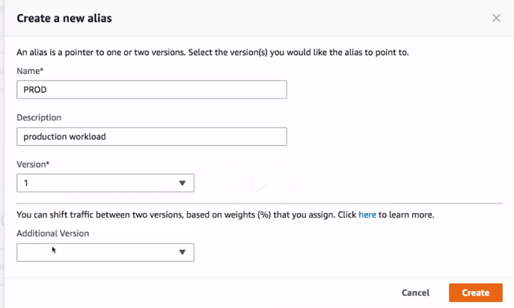
Lambda has also has an option of Slow Shift Blue Green deployments or Canary Style deployments
We can have alias for DEV, QA PROD.

OUTPUTS AND TIMEOUT:

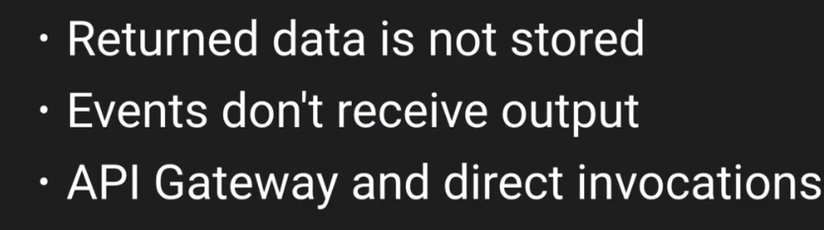

Note :
S3 ,DynamoDB , any service which awe are invoking AWS Lambda will not auto save . We have to Provide an option of storing .

Lambda will not tell for Timeout , (You have this much time only left).
Everytime we need to POLL for TimeOut leftout for the function

Limitations in Lambda Function:
    - What if you Run Out of Time? For Example when data is being written to a databases ,only few tables are written , some tables are left .
For Ecample if there are multiple databases , one database writing is completed , but its pending to write in another database ?

Under these situations we will not be knowing at what state the lambda Function is currently at.

    - What if you Run Out of Memory ?
    - API gateway Requests have 30 Seconds Hard Limit .
    - But Lambda has SoftLimit 3 Seconds to 15 mins .

Solutions For Limitations :

- What Can be done if My workload cannot be completed in 15mins
First Step is to Refactor the workload , so that it can fit in 5 mins .
Splitting of Job into smaller bits .
Spin out Multiple Jobs from one .(Instead of SQS holding back all the jobs ,if the SQS is replaced by a lambda Function which can split the job and spin out several other jobs)

Use Another Services :
AWS Fargate - Container Run Time , Easier to Run than Classic ECS . You pay for the second you use for Fargate Container

AWS Batch- Data Processing workloads Bigdata
S3 Select – Polling Values out of Structured S3 Objects .

Lab 02 :

Goals :
Read input from Kinesis
Track net profits
Log Ouputs to cloudwatch

Kinesis :
1.Logs are ordered streams
2.Events gets batches of records
3.Fast writes

Write Fast Read Fast

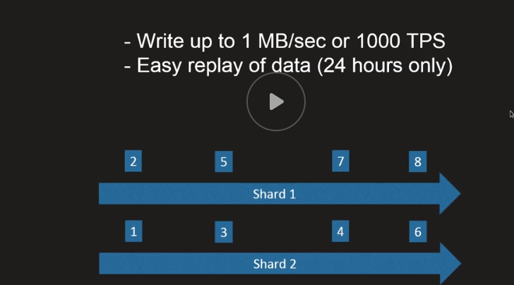

- Create a Data Stream
- Create and Kinesislambda Policy to an IAM Role .

Kinesis :

By default all the kinesis data is base64Encoded . Before Creating the test Event we have to convert to base64 from our normal payload value .

Number of shards is present in a Stream . Each Shard has several set of tasks (boxes numbered in diagram) . To Lambda we can pass many events , and in Batch we will mention the number of records .

Batch Maximum 100 records can be processed and lower limit is 1 record .

Lab 03:

Goals:
- DynamoDB Basics
- DateStamp incoming transactions
- Use DynamoDB triggers

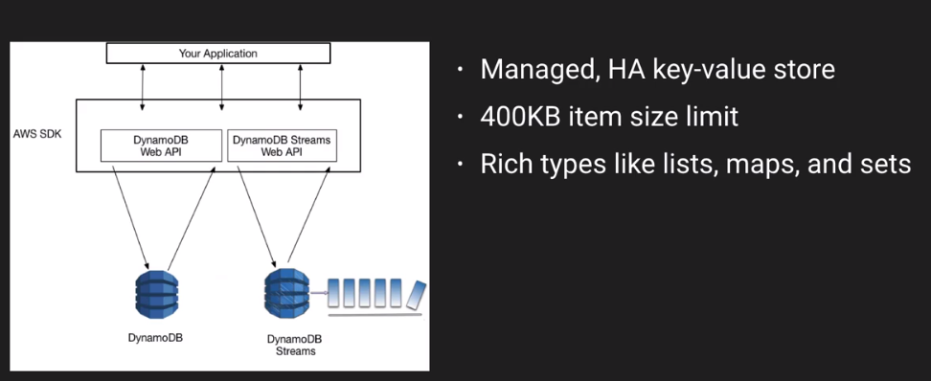
Managed , High Availability , Key Value Store

What Key Value Store means : It doesnt have a full Relational Key Set for querying .
Each Value Should have Unique Key (Ex : TransactionID)

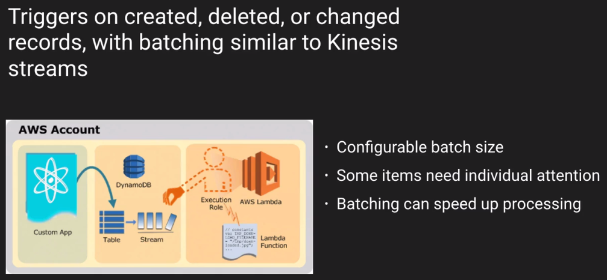

An Event in the DynamoDB table might be the created Item , and that created Item will create an event in the DynamoDb Stream , will then invoke the lambda function

Instead of configuring Environment variables , we can use SSM , KMS to Manage Secrets .

We will be creating an Item in Dynamo DB Table , it will fetch the inputs along with the Primary Key (Unique Key ID for eg : txid) we will provide some net and gross values and immediately after entering
the values in table , lambda function automatically calculates and populates the total value and timestamp column and update in Dynamo DB table . And it also gets logged in Cloudwatch .

Aws Cloud Formation

AcloudGuru CloudFormation :

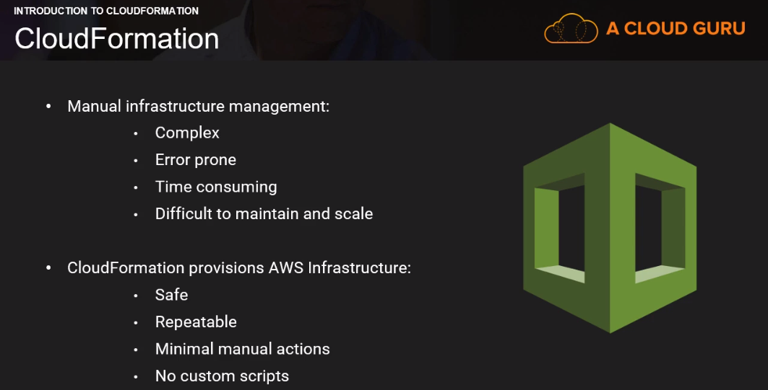

Infrastructure As Code :
A way to manage :
    - Configurations
    - Provisioning
    - Deployments

Tools from Software Development applied to infrastructure
    - Version Control
    - Testing
    - CI/CD

Benefits of using this tooling on infrastructure:
    - Cost reduction
    - Speed
    - Less Risk

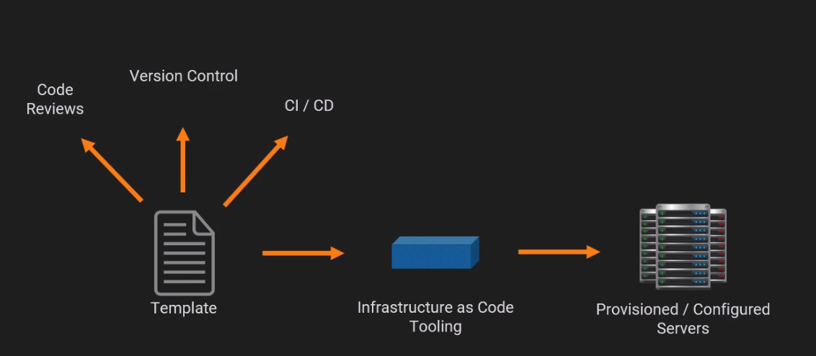
Template → Blueprint .
Infrastructure as code → Chef, Puppet, Terraform ,

